Sprint 1

|  |  |
| --- | --- |
| Date | 29 October 2022 |
| TEAM ID | PNT2022TMID21685 |
| Project Name | IoT Based smart crop Protection system for agriculture |
| Maximum mark | 20 marks |

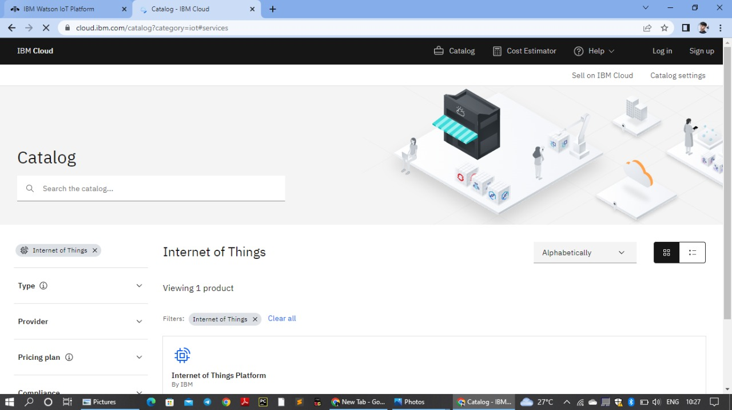

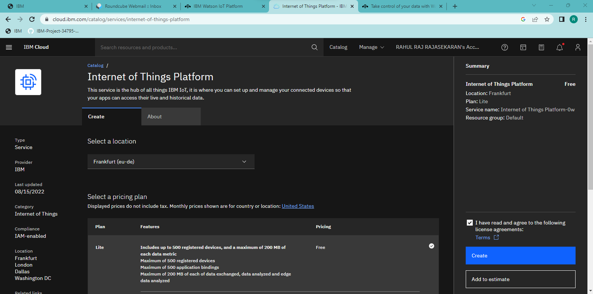

Device credentials information;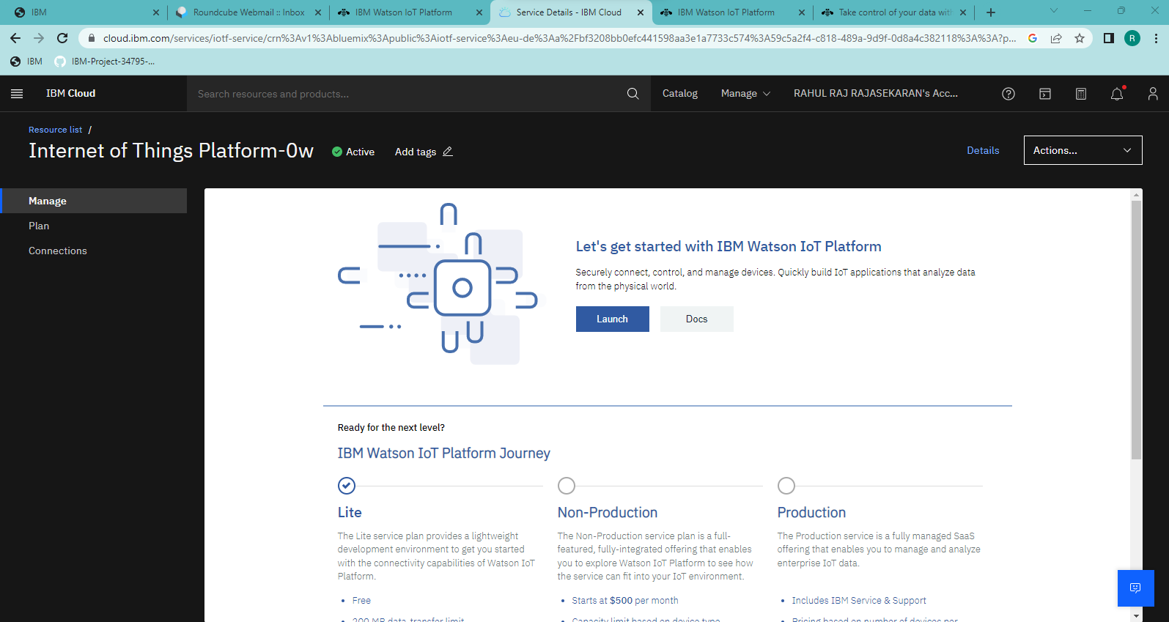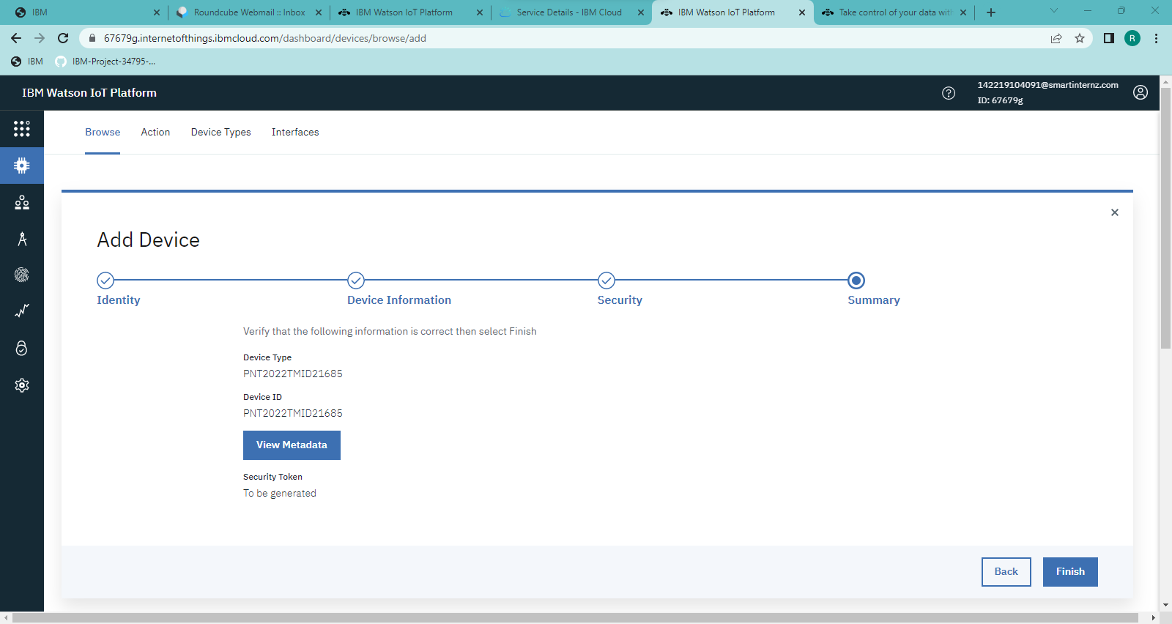

0utput;